**ENEL102, fall term 2017**

**Assignment 6**

**Solving Differential Equations**

**Due date: Nov 27, 2017**

**Donald Robert Dunn**

**10152653**

Assignment questions based on material in the Gilat textbook in section 9.4. Fill in the following template with your answers using Matlab plots and screen shots as necessary. Then submit your Word document on D2L. ………………………………………………………………………………………………………………………………..

**Q1** Consider the simplest differential equation given as



Solution to this is simply x=t. Set this up with Matlabs ode45() to verify this. Solve the DEQ for the range of  using ode45().

**(Matlab input)**

trange = [0 1];

x0 = 0;

ode45(@(t,g) 1, trange, x0)

xlabel('time')

ylabel('X')

title('X = time Plot')

**(Matlab Response)**

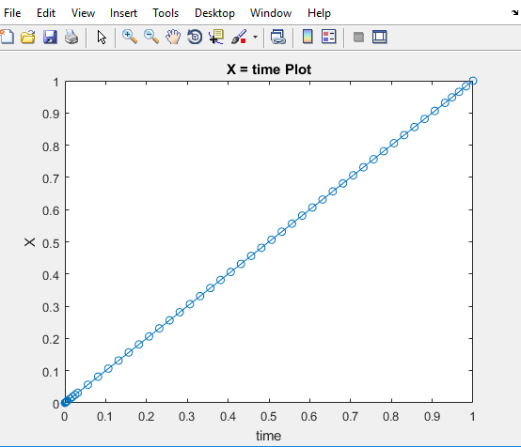

……………………………………………………………………………………………………………………………

**Q2** Consider the next simplest differential equation given as



Solution to this is . As before set this up with Matlabs ode45() to verify this. Solve the DEQ for the range of  using ode45().

**(Matlab input)**

trange=[0 1];

x0=0;

ode45(@(t,x) t, trange,x0)

xlabel('time')

ylabel('X')

title('X = t^2/2');

**(Matlab Response)**

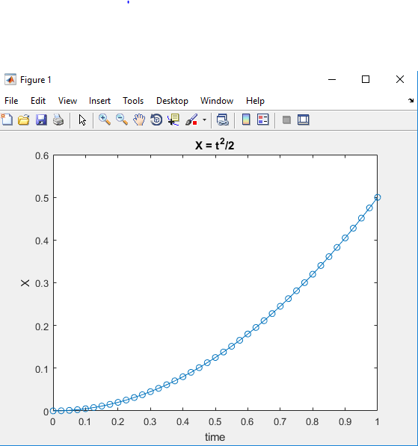

……………………………………………………………………………………………………………………………

**Q3** Consider another linear differential equation given as



Solution to this is



As before set this up with Matlabs ode45() to verify this. Solve the DEQ for the range of  using ode45().

**(Matlab input)**

trange = [0 1];

x0 = 1;

ode45(@(t,x)x, trange, 1)

xlabel('time')

ylabel('X')

title('X = e^t')

**(Matlab Response)**

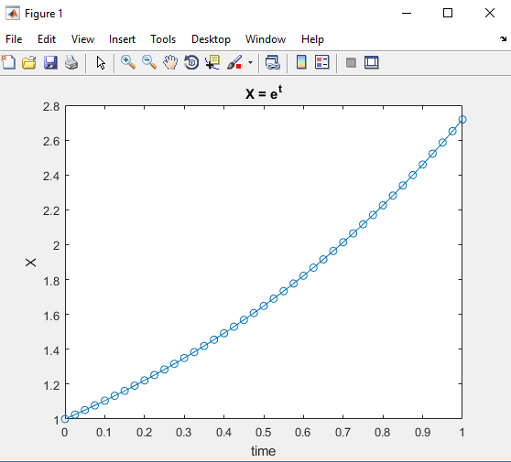

……………………………………………………………………………………………………………………………

**Q4** Now consider a series circuit consisting of a voltage source, v(t), that switches from 0 to 1 volts at t=0 which is connected in series with an inductor L and a resistor R. Assume that the current is to be determined. The DEQ for this circuit is given as



Assume that L=R=1. Solve for the current for the range in time from 0<t<10.

**(Matlab input)**

Resistance = 1;

Inductance = 1;

d = @ (t,v) (heaviside(t)-v*Resistance)/Inductance;

ode45(d, 0:0.5:10 ,0);

ylabel('current')

xlabel('time')

title('Current responce of RL circuit')

**(Matlab Response)**

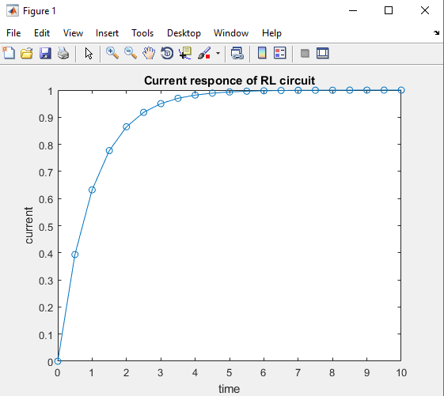

**Q5** Next consider a mass of M=1Kg that is suspended on a spring with an stiffness constant of k=100n/m. The weight is initially held such that the tension through the spring is zero. Then at time t=0 the weight is released. Find the displacement of the weight over the time interval of 0<t<10. Note that the DEQ for this example is given as



**(Matlab input)**

trange = [0 10];

sd = @(t,x) [x(2); -100*x(1) + 9.8];

[t, W] = ode45(sd, trange, [0; 0]);

plot(t, W(:, 1))

ylabel('displacement of weight')

xlabel('time')

title('Weight displacement plot')

**(Matlab Response)**

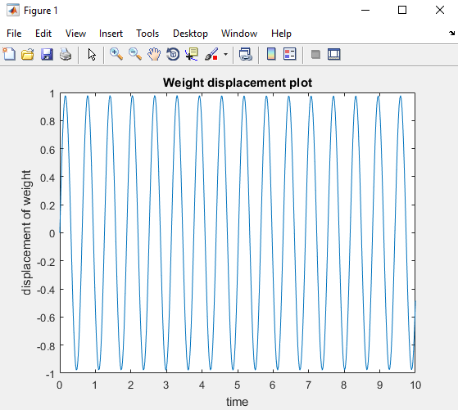

……………………………………………………………………………………………………………………………

**Q6** Next consider a series LRC circuit which has a Laplace transform of



Assume initial conditions of zero for the two state variables and that a unit step function is applied at t=0. Use ode45() to compute the step response. Plot the step response and the derivative of the step response over the time interval of t=0 to t=30.

**(Matlab input)**

f = @(t,ramp) [ramp(2); 0.1-0.1*ramp(2)-ramp(1)];

ode45(f, [0 30], [0 0]);

title('Step Response of system');

xlabel('time');

ylabel('ramp');

**(Matlab Response)**

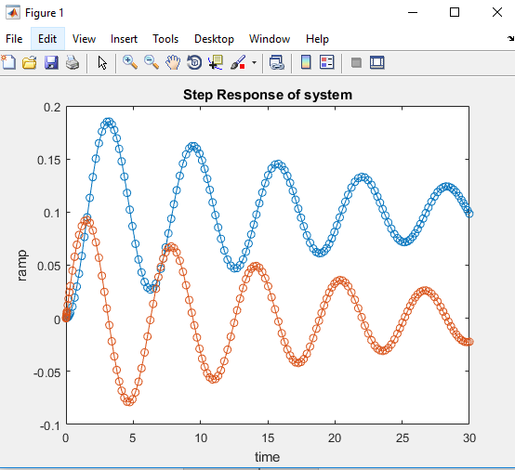

……………………………………………………………………………………………………………………………

**Q7** Repeat Q6 but this time use the functions tf() and step() from the control system toolbox to directly calculate the step response. Plot this solution and overlay the solution calculated in Q6 on the same plot for comparison.

**(Matlab input)**

x0 = [0 0];

trange = [0 30];

f = @(time,y) [y(2); 0.1-0.1*y(2)-y(1)];

ode45(f, trange, x0);

ramp = tf([0.1 0], [1 0.1 1]);

hold on

step(ramp);

title('Direct Step Responce of system');

xlabel('This title is followed by seconds no matter what I do');

ylabel('ramp');

hold off

**(Matlab Response)**



